1. **Input:**

x = 1; y = 5 ; z = 8 ; w = x + y * z;

Output

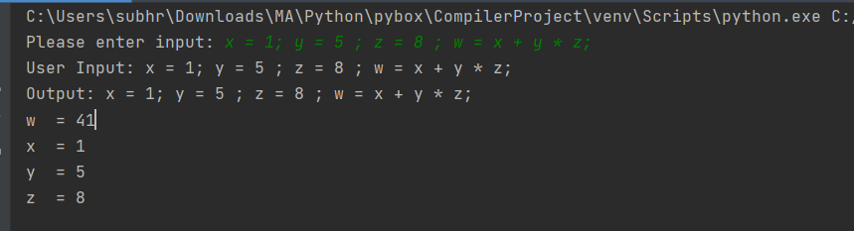

1. **Input:**

x = 1; y = 5 ; z = 8 ; w = -(x + y) * z;

Output

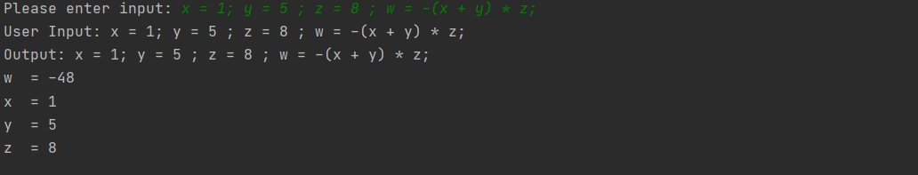

1. **Input:**

x = 3; y= 7; z = 5; w = (x + y)* z

Output

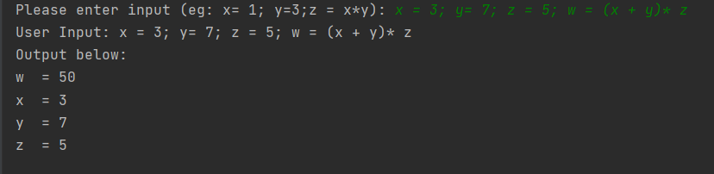

1. **Input:**

x = 3; y= -10; z = 3; w = (x + y)* z

output

